ATTACHMENT E
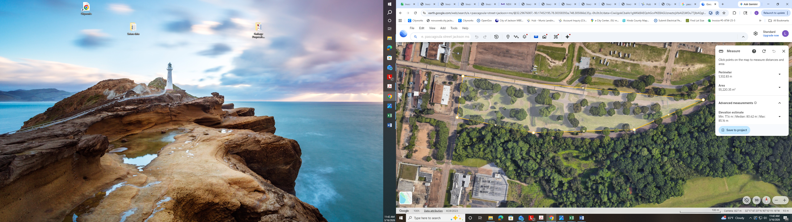
Pascagoula Greenspace

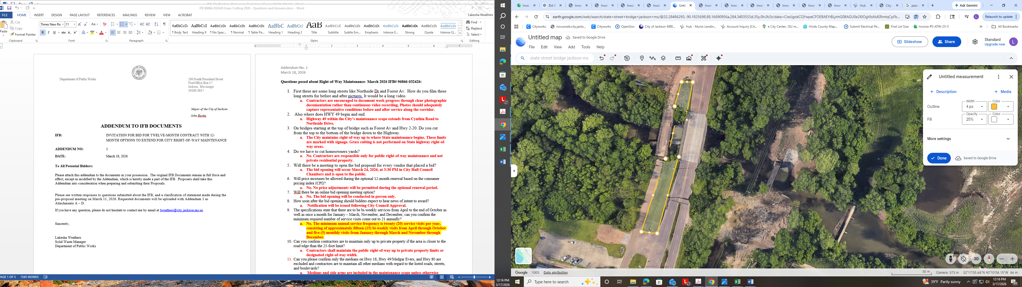

State Street Bridge

