ATTACHMENT A
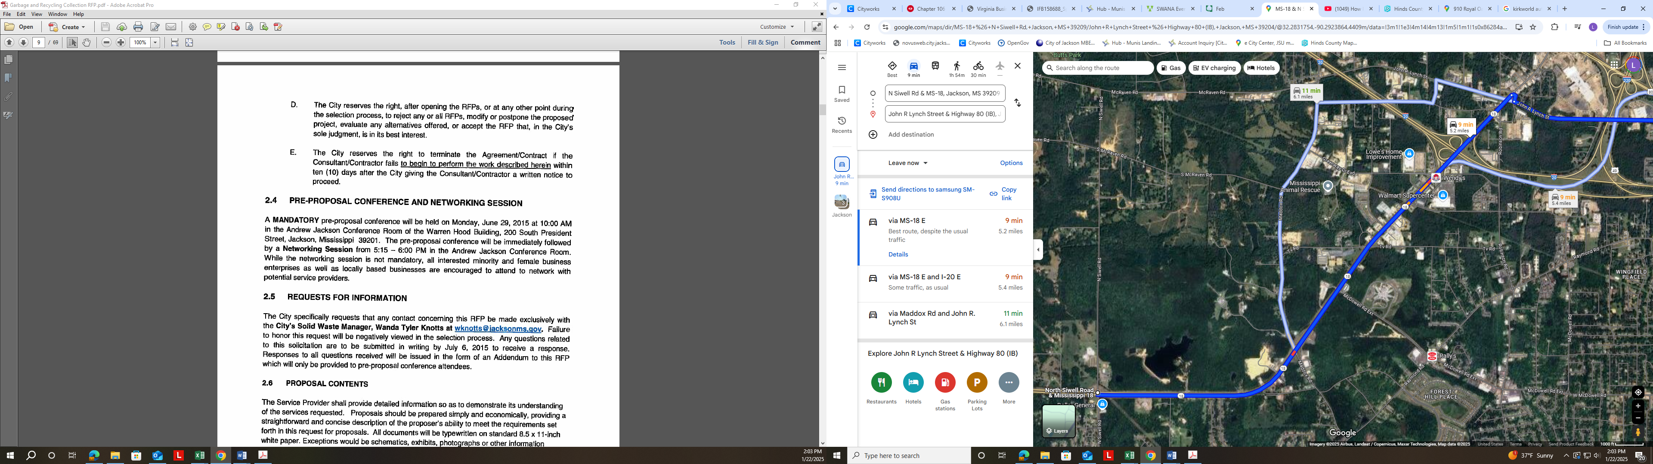
HIGHWAY 18, SIWELL ROAD TO LYNCH STREET
ATTACHMENT B
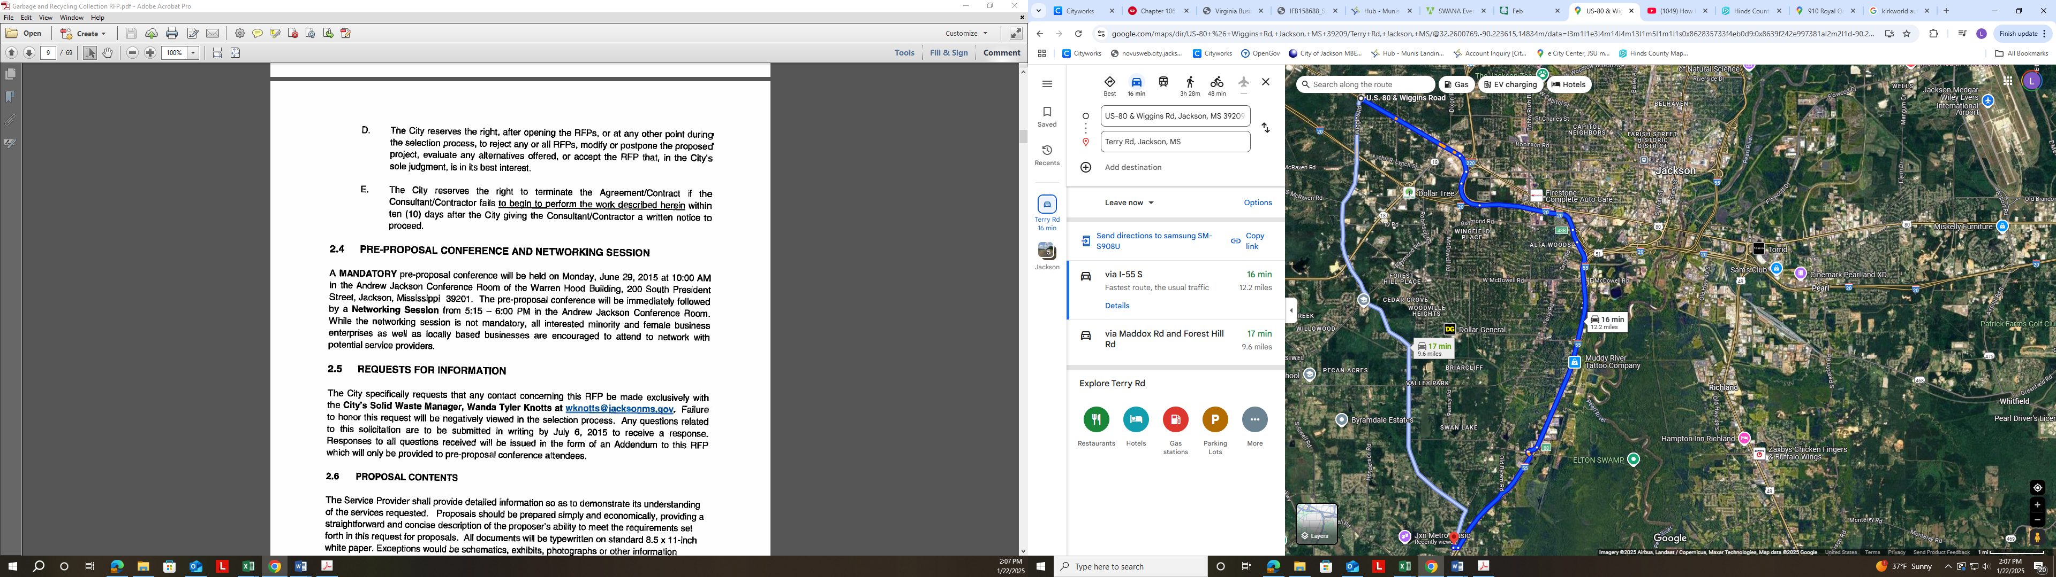
HIGHWAY 80, WIGGINS ROAD TO TERRY ROAD
ATTACHMENT C
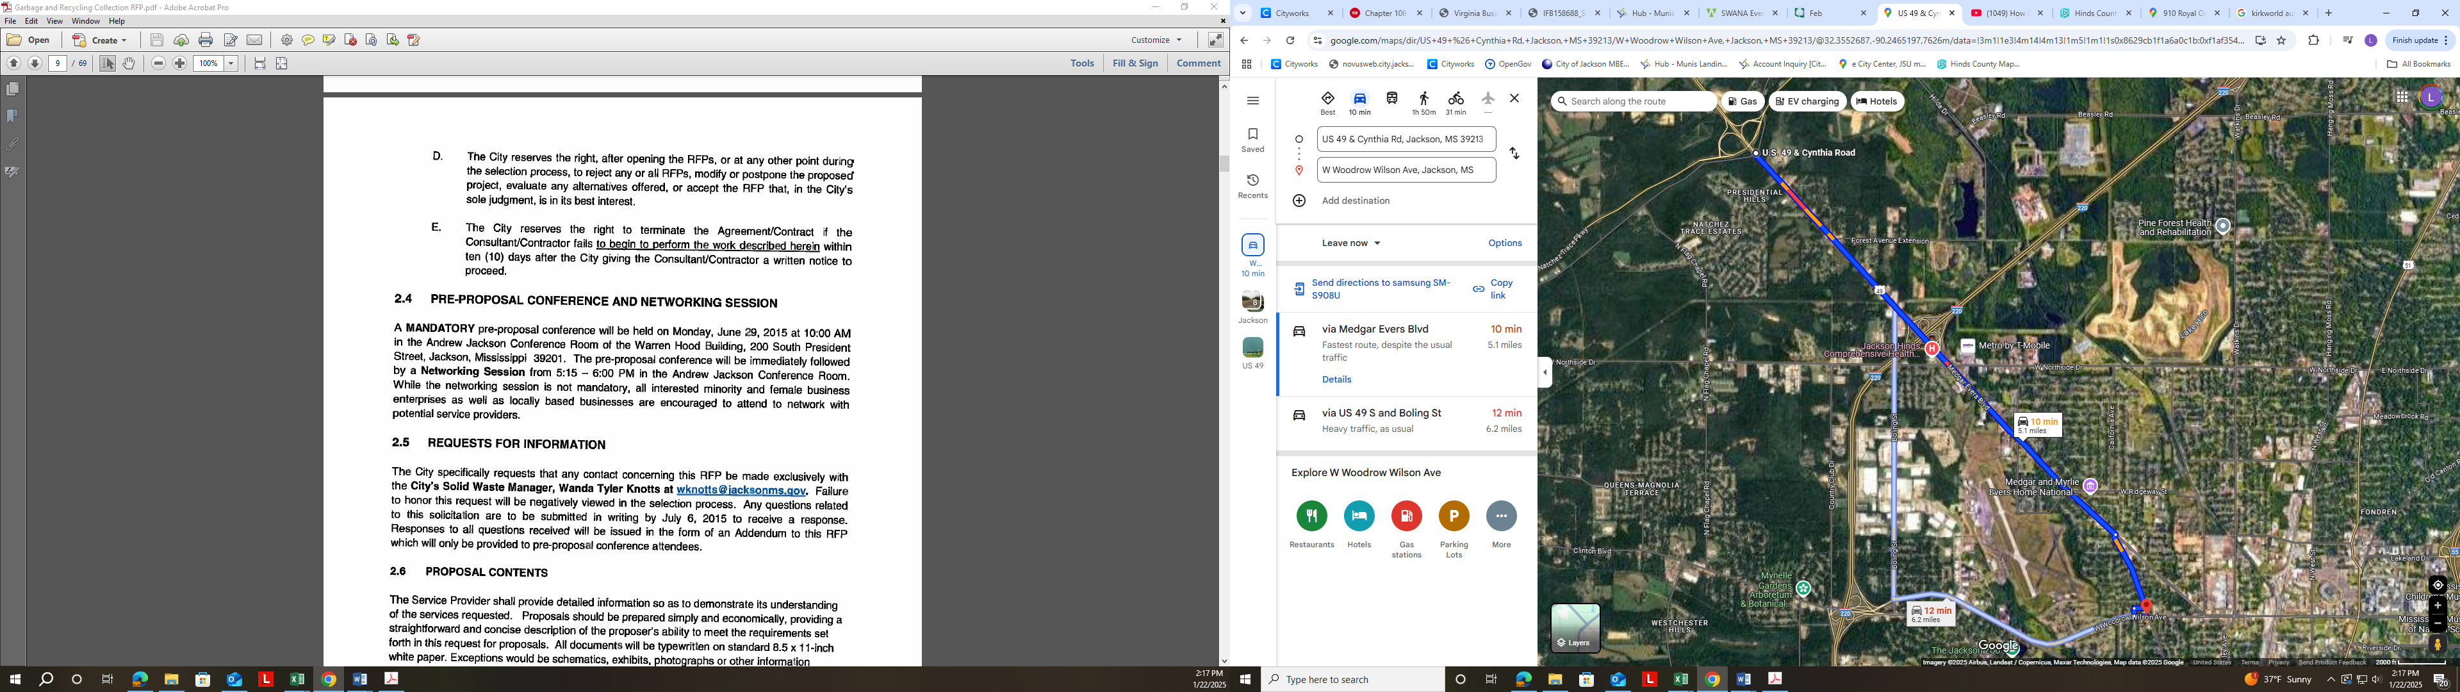
US 49, CYNTHIA ROAD TO WOODROW WILSON

